**[04-IterationControlStructures](https://www.rajalakshmicolleges.net/moodle/course/view.php?id=84&section-4)**

**Ex. No. : 4.1 Date: 17/4/24**

**Register No.: 231801160 Name: Sathvikha**

## [Factorsofanumber](https://www.rajalakshmicolleges.net/moodle/mod/quiz/view.php?id=5720)

Determine the factorsof a number (i.e., all positive integer values that evenly divide into a number).

**For example:**

|  |  |  |
| --- | --- | --- |
| **Input** | **Result** |  |
| 20 | 124 510  20 |  |

# Program:

k=int(input()) l=[]

foriinrange(1,k+1): if(k%i==0):

l.append(i) for j in l:

print(j,end='')

# Output:

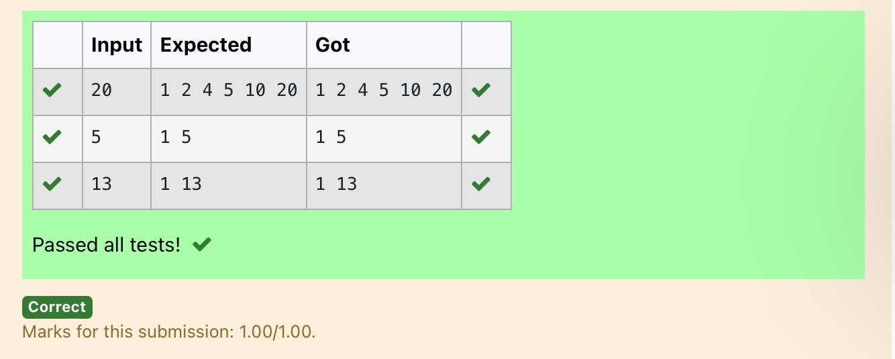

**Ex. No. : 4.2 Date: 17/4/24**

**Register No.: 231801160 Name: Sathvikha**

## [Non](https://www.rajalakshmicolleges.net/moodle/mod/quiz/view.php?id=5717)RepeatedDigitCount

Write a program to find the count of non-repeated digits in a given number N. Thenumber will be passed to the program as an input of type int.

Assumption:Theinputnumberwillbeapositiveintegernumber>=1and<=25000. Some examples are as below.

If the given number is 292, the program should return 1 because there is only 1 non- repeated digit '9' in this number

If the given number is 1015, the program should return 2 because there are 2 non-repeated digits in this number, '0', and '5'.

Ifthegivennumberis108,theprogramshouldreturn3becausethereare3non- repeated digits in this number, '1', '0', and '8'.

If the given number is 22,the function should return 0 because there are NO non-repeated digits in this number.

**For example:**

|  |  |
| --- | --- |
| **Input** | **Resul t** |
| 292 | 1 |
| 1015 | 2 |
| 108 | 3 |
| 22 | 0 |

# Program:

n=int(input()) l=[]

k=[]

while n>0: a=n%10 n=n//10 l.append(a)

foriinrange(len(l)): ifl.count(l[i])==1:

k.append(l[i])

print(len(k))

# Output:

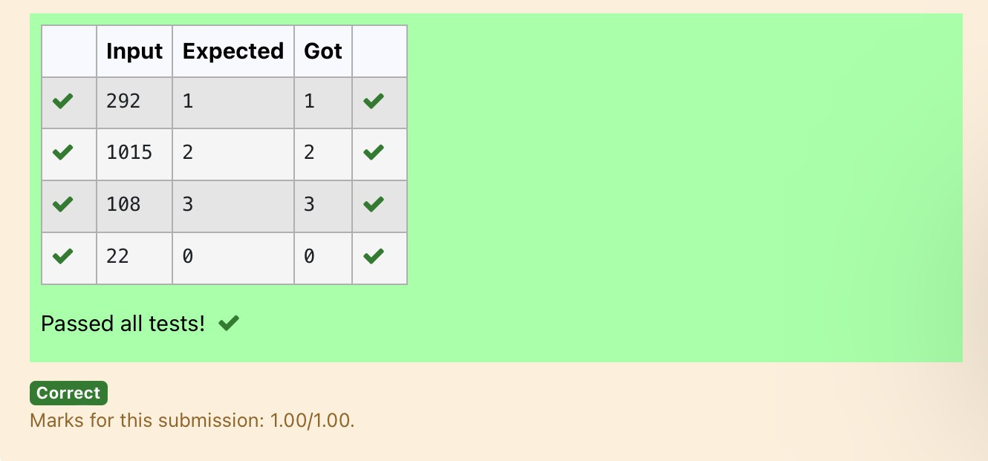

**Ex. No. : 4.3 Date: 17/4/24**

**Register No.: 231801160 Name: Sathvikha**

## PrimeChecking

WriteaprogramthatfindswhetherthegivennumberNisPrimeornot.Ifthenumber is prime, the program should return 2 else it must return 1.

Assumption: 2 <= N <=5000, where N is the given number. Example1: if the given number N is 7, the method must return 2 Example2:ifthegivennumberNis10,themethodmustreturn1

**For example:**

|  |  |
| --- | --- |
| **Input** | **Result** |
| 7 | 2 |
| 10 | 1 |

# Program:

a=int(input())

foriinrange(2,a): if(a%2==0):

flag=0 elif(a%i!=0): flag=1

else:

flag=0 if(flag==1):

print("2") elif(flag==0):

print("1")

# Output:

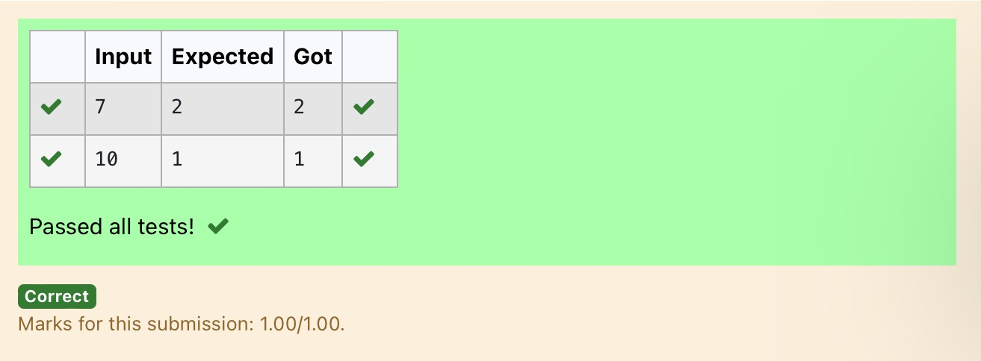

**Ex. No. : 4.4 Date: 24/4/24**

**Register No.: 231801160 Name: Sathvikha**

## NextPerfectSquare

GivenanumberN,findthenextperfectsquaregreaterthanN. Input Format:

Integerinputfromstdin. Output Format:

PerfectsquaregreaterthanN. Example Input:

10

Output:

16

# Program:

a=int(input()) c=[]

foriinrange(0,a): b=i**2

if(b>a):

c.append(b) print(c[0])

# Output:

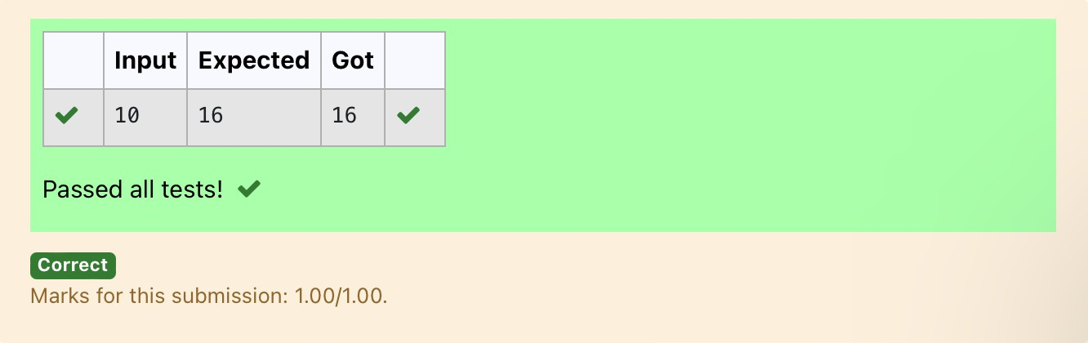

**Ex. No. : 4.5 Date: 24/4/24**

**Register No.: 231801160 Name: Sathvikha**

## NthFibonacci

Writea[program](https://www.rajalakshmicolleges.net/moodle/mod/quiz/view.php?id=3478)toreturnthenthnumberinthefibonacciseries.ThevalueofNwill be passed to the [program](https://www.rajalakshmicolleges.net/moodle/mod/quiz/view.php?id=3478) as input.

NOTE:Fibonacciserieslookslike –

0,1, 1, 2,3, 5,8,13,21, 34,55, ... andsoon.

i.e.Fibonacciseriesstartswith0and1,andcontinuesgeneratingthenextnumber as the sum of the previous two numbers.

* firstFibonaccinumberis0,
* secondFibonaccinumberis 1,
* thirdFibonaccinumberis1,
* fourthFibonaccinumberis2,
* fifthFibonaccinumberis 3,
* sixthFibonaccinumberis5,
* seventhFibonaccinumberis8,andsoon.

**For example:**

**Input:**

**7**

**Output 8**

# Program:

a=[0,1]

for i in range(0,100): a.append(a[-1]+a[-2])

q=int(input()) print(a[q-1])

# Output:

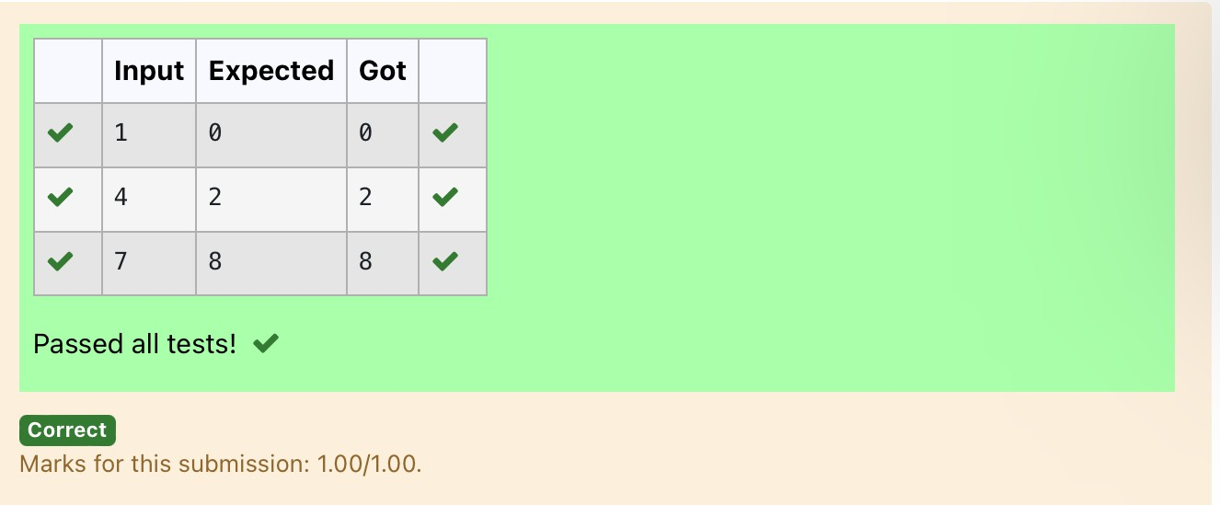

**Ex. No. : 4.6 Date: 24/4/24**

**Register No.: 231801160 Name: Sathvikha**

## DisariumNumber

ANumberissaidtobeDisariumnumberwhenthesumofitsdigitraisedtothepower of their respective positions becomes equal to the number itself. Write a [program](https://www.rajalakshmicolleges.net/moodle/mod/quiz/view.php?id=3478)to print number is Disarium or not.

InputFormat:

SingleIntegerInputfromstdin. Output Format:

YesorNo.

ExampleInput:

175

Output:

Yes Explanation

1^1+7^2+5^3=175

ExampleInput: 123

Output:

No

**For example:**

|  |  |
| --- | --- |
| **Input** | **Res ult** |
| 175 | Yes |
| 123 | No |

importmath

# Program:

n=int(input()) a=len(str(n)) sum=0

x=n while(x!=0):

r=x%10 sum=int(sum+math.pow(r,a)) a-=1

x=x//10 if(sum==n):

print("Yes") else:

print("No")

# Output:

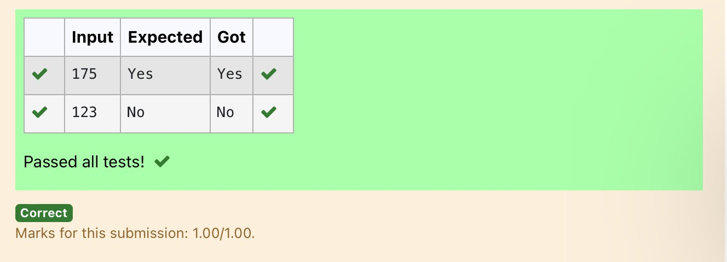

**Ex. No. : 4.7 Date: 24/4/24**

**Register No.: 231801160 Name: Sathvikha**

## SumofSeries

Writeaprogramtofindthesumoftheseries1+11+111+1111+...+nterms(n will be given as input from the user and sum will be the output)

SampleTestCases Test Case 1

Input 4

Output 1234

Explanation:

asinputis4,havetotake4terms. 1 + 11 + 111 + 1111

TestCase2 Input

6

Output 123456

**For example:**

|  |  |
| --- | --- |
| **Input** | **Result** |
| 3 | 123 |

# Program:

n=int(input()) b=1

sum=0

fori in range(1,n+1):

sum+=b b=(b*10)+1

print(sum)

# Output:

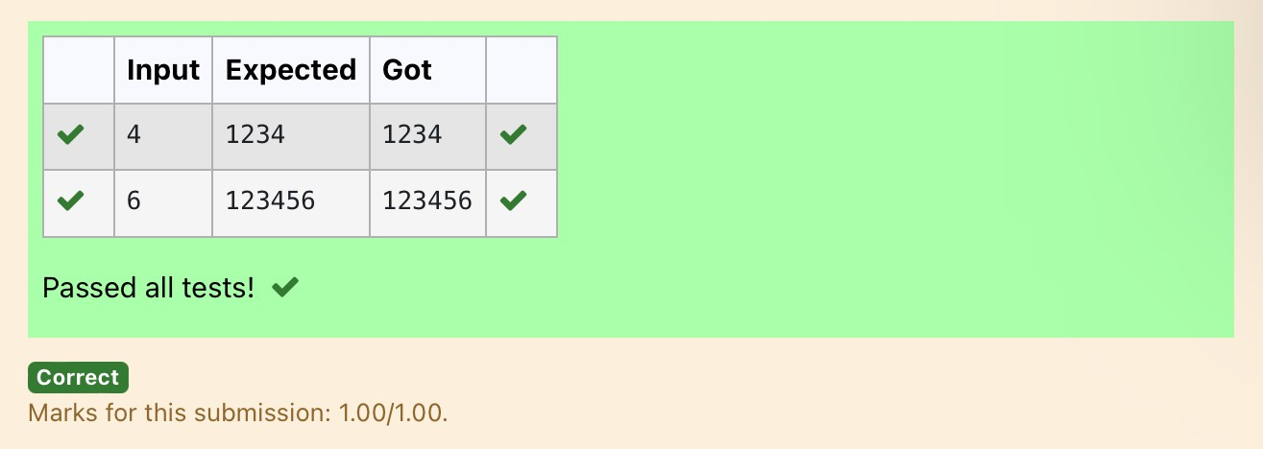

**Ex. No. : 4.8 Date: 24/4/24**

**Register No.: 231801160 Name: Sathvikha**

## UniqueDigitCount

Write a programto find the count ofuniquedigitsin a given number N. Thenumber will be passed to the program as an input of type int.

Assumption:Theinputnumberwillbeapositiveintegernumber>=1and<=25000. For e.g.

Ifthegivennumberis292,theprogramshouldreturn2becausethereareonly2 unique digits '2' and '9' in this number

Ifthegivennumber is1015,theprogramshouldreturn3becausethereare3unique digits in this number, '1', '0', and '5'.

**For example:**

|  |  |
| --- | --- |
| **Input** | **Result** |
| 292 | 2 |
| 1015 | 3 |

# Program:

a=int(input()) b=[]

while a>0: c=a%10 a=a//10 b.append(c)

b=list(set(b)) print(len(b))

# Output:

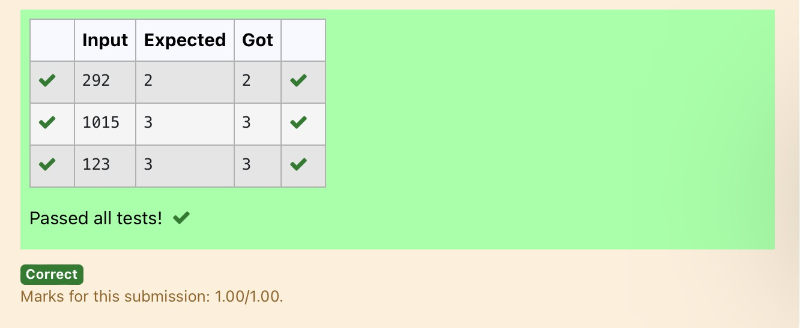

**Ex. No. : 4.9 Date: 24/4/24**

**Register No.: 231801160 Name: Sathvikha**

## Productofsingledigit

GivenapositiveintegerN,checkwhetheritcanberepresentedasaproductofsingle digit numbers.

InputFormat:

SingleInteger input.

OutputFormat:

OutputdisplaysYesifconditionsatisfieselseprintsNo. Example Input:

14

Output:

Yes

ExampleInput: 13

Output:

No

# Program:

a=int(input()) flag=0

for i in range(10): forjinrange(10):

if(i*j==a): flag=1 break

if(flag==1): print("Yes")

else:

print("No")

# Output:

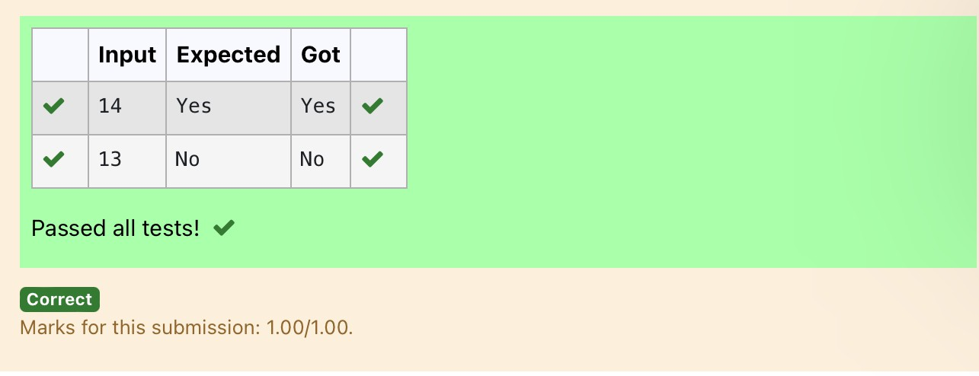

**Ex. No. : 4.10 Date: 1/5/24**

**Register No.: 231801160 Name: Sathvikha**

## PerfectSquareAfteraddingOne

GivenanintegerN,checkwhetherNthegivennumbercanbemadeaperfectsquare after adding 1 to it.

Input Format: Singleintegerinput. Output Format:

YesorNo.

ExampleInput:

24

Output:

Yes

ExampleInput: 26

Output:

No

**For example:**

|  |  |
| --- | --- |
| **Input** | **Resul t** |
| 24 | Yes |

# Program:

import math n=int(input())a=n+1 sr=int(math.sqrt(a))

if(sr*sr==a): print("Yes")

else:

print("No")

Output:

